# **Phase 6: User Interface Development**

**Built Lightning App → “EduConnect CRM”**

* Created a **centralized app** in Salesforce to manage all student, faculty, course, and alumni data.
* Provides a **single navigation interface** for easy access to records, dashboards, and reports.

**Created Record Pages for Students, Faculty, Courses, and Alumni**

* Customized **Lightning Record Pages** for each object.
* Added **Highlights Panel** for key fields, **Tabs** for Details & Related Lists, and **Activity Timeline** for tasks/notes.
* Allows users to **quickly view and manage related information** in one place.

Student Page:

Faculty page:  
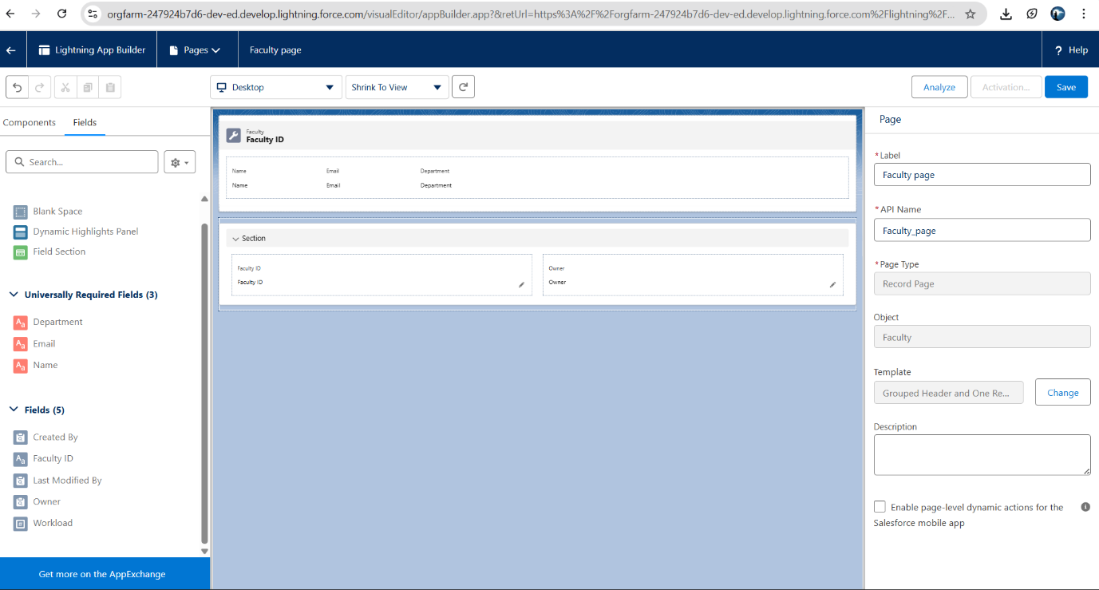

**Added Utility Bar with quick access to Reports & Dashboards**

* Added a **Utility Bar** at the bottom of the app for quick tools.
* Users can **view Reports, Dashboards, Notes, or Recent Items** without navigating away from the page.

**Developed LWC for Faculty Workload Distribution**

* Displays **each faculty member with the number of courses assigned**.
* Helps **management quickly understand faculty workload** and balance course assignments.
* Simple list-based component showing faculty name and course count.

LWC UI code:

Js Code:

XML code:

**Key Achievements in phase 6:**

1. **Lightning App → “EduConnect CRM”**
   * Centralized app with navigation for all modules, reports, and dashboards.
2. **Custom Record Pages**
   * Students, Faculty, Courses, and Alumni have **custom Lightning Record Pages**.
   * Added **Highlights Panel**, **Tabs for Details & Related Lists**, and **Activity Timeline** for better usability.
3. **Utility Bar**
   * Quick access to **Notes, Recent Items, Reports, and Dashboards** from any page.
4. **Lightning Web Component (LWC)**
   * Developed **Faculty Workload Tracker** LWC.
   * Displays **each faculty member with the number of courses assigned**.
   * Helps management **monitor faculty workload** easily.

**Outcome:**

* Users can **view, navigate, and manage records efficiently**.
* Provides **quick insights** into faculty workload.
* Sets a foundation for **future LWCs** like Student Performance or Alumni Engagement.

# **Phase 7: Integration & External Access**

• **Integrated with external LMS API for attendance tracking**

* Connected Salesforce with the **Learning Management System (LMS)**.
* Automatically fetches **student attendance data** to keep records up-to-date.

• **Configured Named Credentials for secure callouts**

* Stores **API endpoint & authentication info** in Salesforce securely.
* Allows Apex or LWCs to make **external HTTP requests safely** without exposing credentials.

• **Built REST API to allow external systems to fetch student performance reports**

* Created a **custom REST API** in Salesforce.
* External systems can **request student grades, progress, and performance summaries**.

• **Used Platform Events for student achievement milestones**

* Sends **real-time notifications** whenever a student completes a milestone (like completing a course).
* Other systems or apps can **subscribe to these events**.

• **Enabled Salesforce Connect for connecting with external university systems**

* Access external data **in real-time inside Salesforce** without importing it.
* Students, Courses, or Faculty from external systems appear as **virtual objects**.

• **Implemented OAuth for secure integrations**

* Ensures **secure authentication and authorization** for external apps accessing Salesforce.
* Protects sensitive data and prevents unauthorized access.

Summary of **Phase 7:**

**Integration & External Access**  
In this phase, Salesforce was extended to integrate with external systems and provide secure, real-time data access. A **Named Credential (LMS_API)** was configured to connect Salesforce with the external Learning Management System, allowing automatic retrieval of student attendance data. A **custom REST API** was developed so that external applications could fetch student performance reports, including grades, GPA, and status. **Platform Events** were used to send real-time notifications whenever a student reached achievement milestones, enabling instant updates across systems. **Salesforce Connect** was set up to link external university databases, bringing in student, faculty, and course information as virtual objects without importing data. Finally, a **Connected App with OAuth** was implemented to provide secure authentication for external applications, ensuring that only authorized systems can access Salesforce data.

# **Phase 8: Data Management & Deployment**

**1️⃣ Data Import Wizard**

The **Data Import Wizard** in Salesforce allows you to easily upload small to medium amounts of data for standard or custom objects. In this project, it was used to import the initial set of **Student** and **Faculty** records, ensuring that the CRM had all essential information before moving on to enrollments or other operations. It provides a user-friendly interface and mapping options to match CSV columns with Salesforce fields.

**2️⃣ Data Loader**

For larger volumes of data, such as multiple **enrollments**, the **Data Loader** tool was used. Data Loader can handle bulk insertions, updates, or deletions, making it ideal for enrolling many students into courses at once. It ensures that operations are performed  
efficiently and supports error logging to identify issues with any records during the process.

**3️⃣ Duplicate Rules**

To maintain data integrity, **Duplicate Rules** were implemented. These rules automatically check for existing records when a new student or faculty record is created, preventing duplicates. This ensures that each student and faculty member has a unique record, avoiding confusion and inconsistencies in reporting or workflows.

**4️⃣ Scheduled Data Export**

Regular backups are essential for disaster recovery and compliance. **Scheduled Data Export** was configured to automatically export data from Salesforce on a weekly basis. This ensures that all student, faculty, and enrollment data is backed up securely and can be restored if needed, providing peace of mind and safeguarding critical information.

**5️⃣ Deployment with Change Sets**

After completing development and testing in the sandbox, **Change Sets** were used to deploy metadata and configuration to the production environment. Change Sets provide a simple way to move objects, record types, workflows, and other customizations between environments, ensuring that the live system mirrors the tested sandbox setup.

**6️⃣ Advanced Deployment: ANT Migration Tool & SFDX with GitHub**

Implementation Summary: Setting up a source-driven development lifecycle using VS Code and the Salesforce CLI (SFDX) is planned for the future. Project Structure Created: EduLink/

├── force-app/ │ ├

── main/ │ │

└── default/

││ ├── classes/

││ ├── objects/

│ │ ├── flows/

│ │ ├── lwc/ │

│ └── triggers/

├── config/

├── scripts/

└── sfdx-project.json  
  
  
**✅ Phase 8 Checklist**

1. **Data Import Wizard**
   * Upload initial Student records
   * Upload initial Faculty records
2. **Data Loader**
   * Bulk upload Enrollments
   * Verify data consistency
3. **Duplicate Rules**
   * Prevent duplicate Students
   * Prevent duplicate Faculty
4. **Scheduled Data Export**
   * Configure weekly export of all critical objects
   * Verify backup files
5. **Deployment with Change Sets**
   * Move custom objects, fields, workflows, and record pages from Sandbox → Production
6. **Advanced Deployment (Optional)**
   * ANT Migration Tool setup for metadata deployment
   * SFDX + GitHub integration for version control and CI/CD

**Data Management & Deployment – Summary:**

In this phase, Salesforce data was managed and deployed efficiently. The **Data Import Wizard** was used to upload initial student and faculty records, while **Data Loader** handled bulk enrollment data. **Duplicate Rules** ensured unique student and faculty entries. **Scheduled Data Export** provided weekly backups of critical data. Deployments from sandbox to production were done using **Change Sets**, and for advanced automation and version control, **ANT Migration Tool** and **SFDX with GitHub** were available.

# **Phase 9: Reporting, Dashboards & Security Review**

**1️⃣ Reports**

**Student Enrollment by Course**

* Shows the **number of students enrolled in each course**.
* Helps management monitor course popularity, capacity, and trends.

**Faculty Workload Summary**

* Summarizes **courses assigned to each faculty member**.
* Helps balance workload and identify over- or under-assigned faculty.

**Alumni Engagement Statistics**

* Tracks alumni activities like events participation or donations.
* Provides insights into **alumni involvement and engagement** over time.

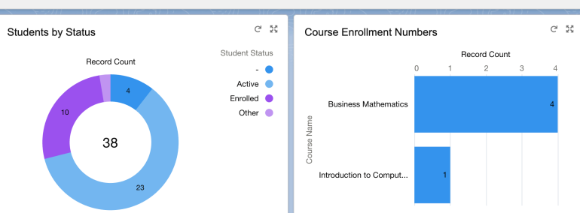

**2️⃣ Dashboards**

**Management Dashboard**

* Visualizes **KPIs** such as total admissions, faculty assignments, and alumni engagement.
* Provides management with a **high-level view of the institution’s performance**.

**Faculty Dashboard**

* Shows **student performance metrics** for the courses they teach.
* Helps faculty **track student progress and identify students needing support**.

**3️⃣ Security**

**Role Hierarchy → Principal > Faculty > Students**

* Defines access levels so **Principals see all data**, **Faculty see assigned students/courses**, and **Students see only their own data**.

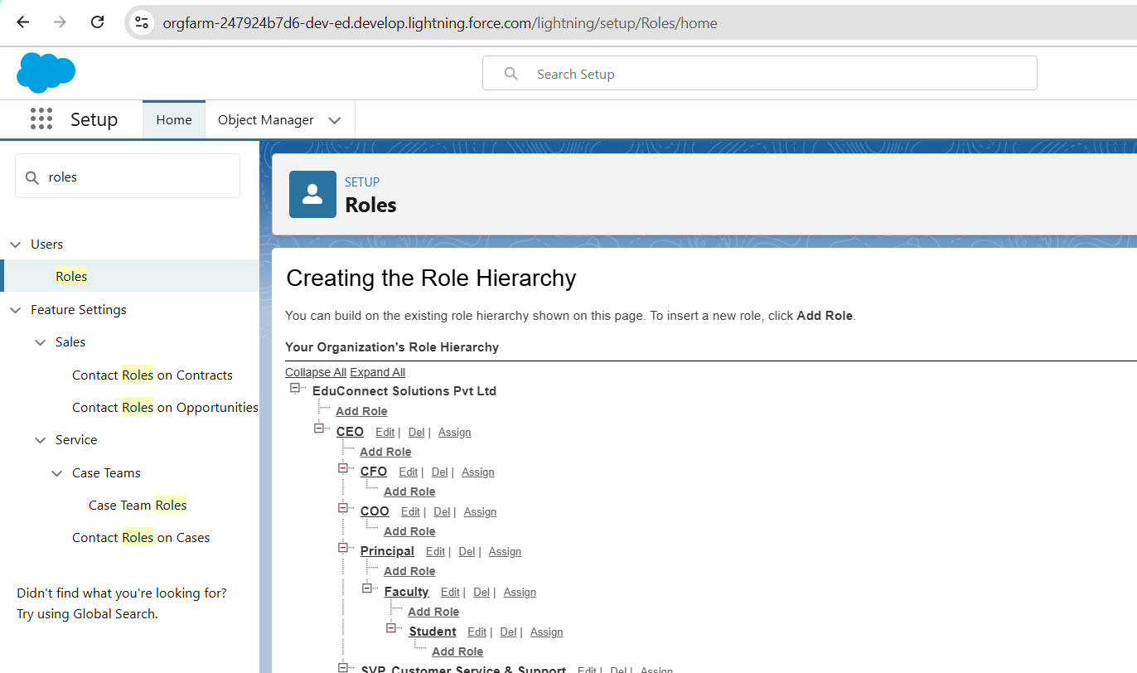

**Field-Level Security**

* Restricts sensitive information (e.g., student grades or personal data) to **authorized users only**.

**Sharing Rules**

* Ensures **Course data is visible only to assigned faculty**.
* Maintains **data privacy and controlled access**.

**Session Settings**

* Enforces **stricter login policies** like session timeouts, IP restrictions, and multi-factor authentication.
* Enhances **overall system security** and compliance.

Summary:

**Reporting, Dashboards & Security Review**  
Create reports for **Student Enrollment by Course**, **Faculty Workload Summary**, and **Alumni Engagement Statistics** to monitor key metrics. Build dashboards including a **Management Dashboard** for admissions, faculty assignments, and alumni engagement, and a **Faculty Dashboard** for tracking student performance. Configure **security** by setting up the role hierarchy (Principal > Faculty > Students), applying **field-level security** to hide sensitive student information, creating **sharing rules** so course data is visible only to assigned faculty, and enforcing **stricter session settings** such as timeouts and multi-factor authentication to ensure secure access.

**Checklist & Description:**

* **Reports:** Create **Student Enrollment by Course**, **Faculty Workload Summary**, and **Alumni Engagement Statistics** reports to track enrollments, faculty assignments, and alumni participation.
* **Dashboards:** Build a **Management Dashboard** to visualize KPIs on admissions, faculty workload, and alumni engagement, and a **Faculty Dashboard** to monitor student performance metrics.
* **Security:** Set up the **role hierarchy** (Principal > Faculty > Students) to define access levels, configure **field-level security** to protect sensitive student information, implement **sharing rules** so course data is only visible to assigned faculty, and enforce **stricter session settings** like timeouts, IP restrictions, and multi-factor authentication.

**Outcome:**

* Accurate and actionable reports and dashboards are available for management and faculty.
* Data is secure and accessible only to authorized users.
* The system follows best practices for role-based access and data privacy.